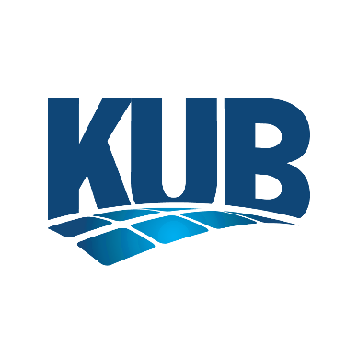

Community Advisory Panel
Meeting Minutes for March 5, 2026

Members attending the meeting:
Nancy Friedrich
Melissa Hinten
Laura Johns
Janet Testerman
Wes Willoughby
Keira Wyatt

Others in attendance:
Dawn Ford, Facilitator

KUB Staff:
Gabe Bolas
Erin Gill
Tiffany Martin
Kurt Stafford
Mark Walker
John Williams

KUB Commissioners:
Phyllis Nichols

New Business
The Community Advisory Panel met at 3:00 p.m. on Thursday, March 5, 2026, at KUB’s Hoskins Operations Center (4505 Middlebrook Pike).

Dawn Ford called the meeting to order.

Ms. Ford asked if there were any changes to the December meeting minutes. There were no changes, and the panel approved the minutes.

Panel members introduced themselves, and Ms. Ford provided an overview of the purpose and structure of the panel.

Gabe Bolas, KUB President & CEO, provided welcoming remarks for the panel.

John Williams, Senior Vice President & Chief Infrastructure & Compliance Officer, presented information about KUB’s emergency preparedness and response for situations when adverse conditions may impact utility services. The presentation included an overview of KUB’s Incident Command Structure, service restoration strategies, and communications to keep customers informed.

Laura Johns asked about the option for KUB to move power lines underground. Mr. Williams explained the significant cost, estimated to be around $10 billion, and how it would impact KUB customer bills. He noted KUB does implement strategic underground projects to improve reliability to the extent possible. Mr. Williams also confirmed KUB’s electric reliability level overall is more than 99.9845% with current infrastructure.

Ms. Wyatt asked about automated infrastructure. Mr. Williams explained all KUB customer meters are automated with capability for remote meter reading. He explained KUB’s smart switch technology and how it allows for automatic restoration of power for many customers when a section of line is damaged. Ms. Wyatt asked when equipment is underground, how quickly can it be repaired and what are some of the downsides? Mr. Williams confirmed that identifying the source of an outage and making repairs for underground electric equipment can be slower.

Janet Testerman asked if the cost of storm restoration would help offset an investment to move power lines underground. Mr. Williams explained that while there would be an offset, storm costs are far less significant compared to the upfront cost of a large-scale underground conversion.

Ms. Johns asked about options for large industrial customers to have notice ahead of outages. She referenced the example of when TVA required intermittent outages during Winter Storm Elliot. Mr. Williams confirmed the TVA grid issue was highly unusual, and KUB was required to take immediate action; however, since that experience, KUB has worked on how to handle that scenario differently if it occurred again. He also noted large industrial customers are supported by Key Account representatives to provide direct support and communication.

Ms. Wyatt asked about training for roles in the Incident Command Structure. Mr. Williams described how training occurs for the different roles and that oftentimes, it is through job shadowing during real events.

Ms. Johns asked how KUB manages safety on the electric system during restoration work. Mr. Williams confirmed KUB de-energizes and grounds the lines to ensure safety.

Nancy Friedrich asked how many customers are enrolled in proactive notifications. Tiffany Martin confirmed approximately 26,000 customers are currently enrolled, and KUB is continuing to promote this option.

Panel members toured KUB’s Customer Information and Operations Centers to learn more about these aspects of KUB’s customer service and operations.

No members of the public addressed the panel during the public forum.

The meeting was adjourned at 4:45 p.m.

This metric has been updated in the minutes to reflect correct current enrollment.

